Analysis Of Number of Manufactures by Year:

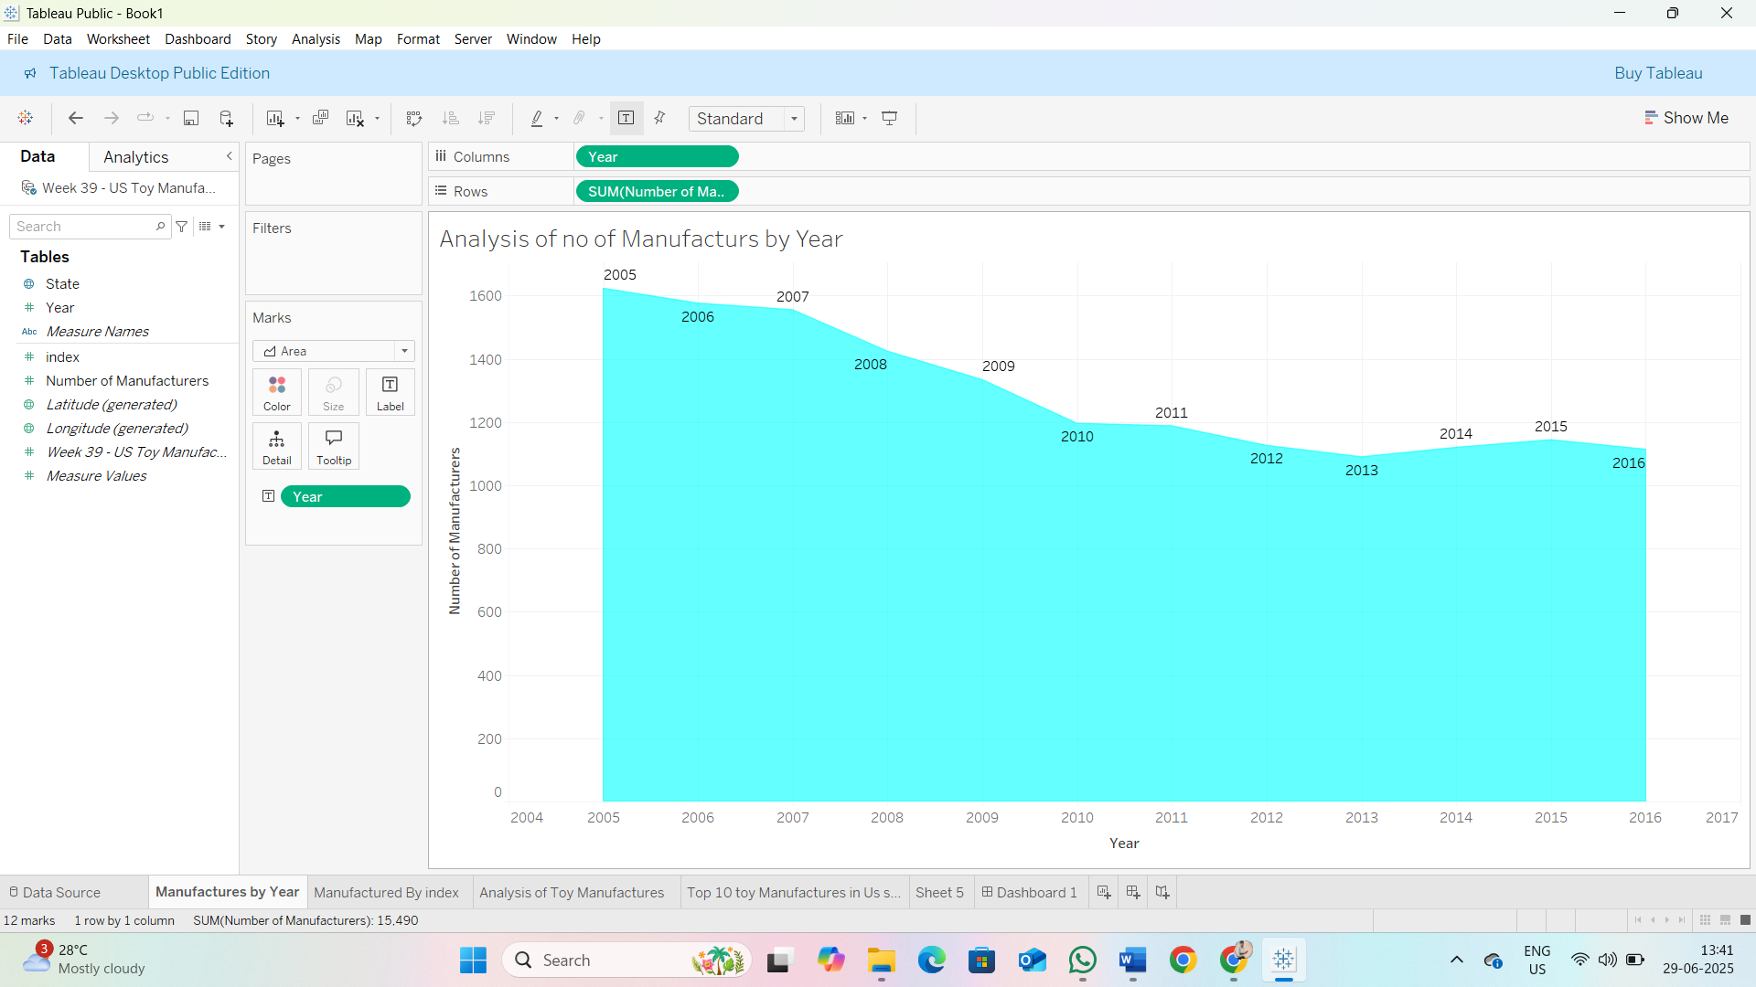

Analysis of Toy Manufactured By index:

Analysis of Toy Manufactures:

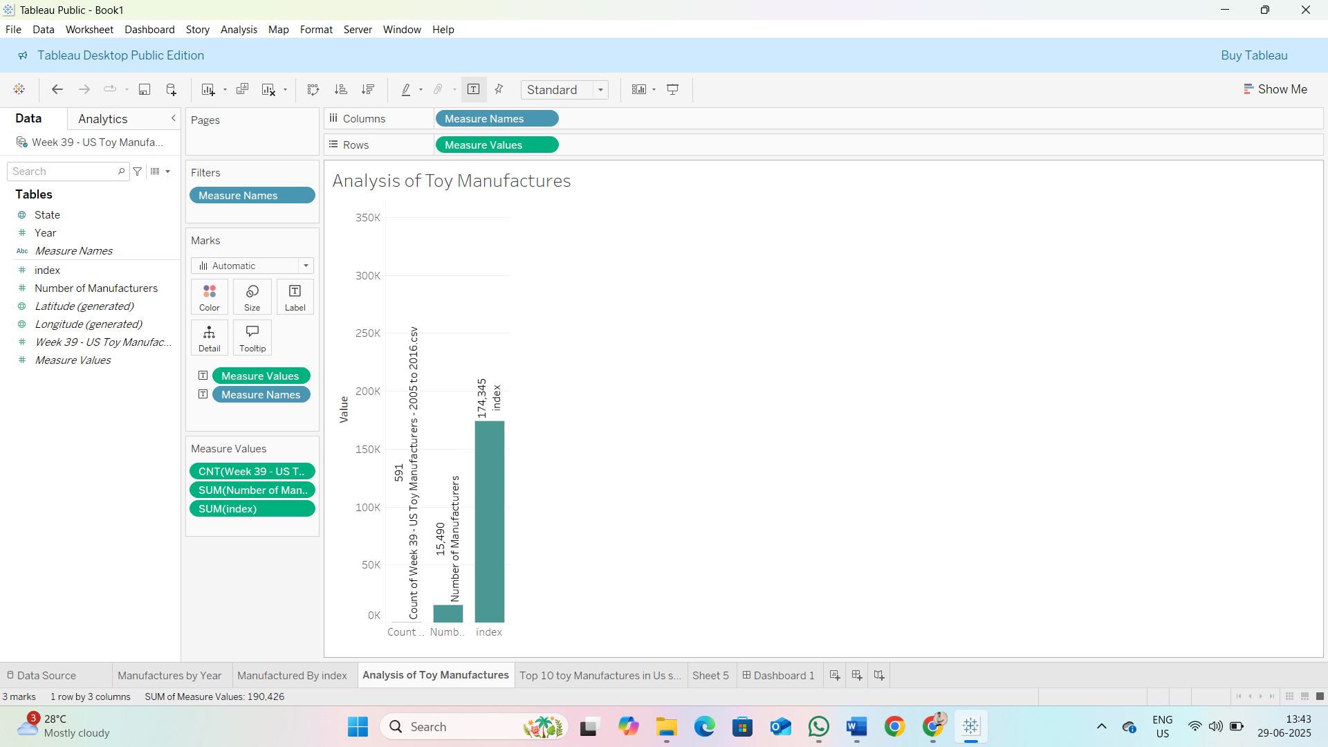

Top 10 States toy Manufactures in Us state:

